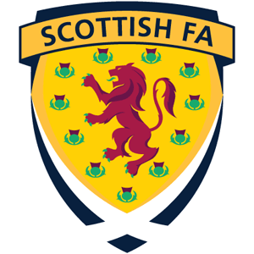
SFA REFEREE DEVELOPMENT AWARD
(S5/6 ONLY)

Introduction

Pupils will develop knowledge and understanding in order to referee a football match. The Course specification has been written in the context of ‘formal controls and procedures’ to accommodate the protocols defined in the ‘Laws of the Game’.

This is essentially a practical Course. Pupils will be provided with the opportunity to develop their knowledge, understanding and ability through experiential learning situations, underpinned with supporting lesson inputs, as and when required.

Recommended Entry Requirements

Pupils should have experience playing football as well as a keen interest in the activity. An understanding of some of the laws of the game will also be necessary.

Pupils should have either Unit or Course awards in Physical Education.

Course Outline

SFA REFEREE DEVELOPMENT AWARD (Pass/Fail)
Scottish FA: Laws of the Game
On completion of the Unit the candidate should be able to:
- Identify and interpret the Laws of the Game.
- Demonstrate the practical skills required to implement the Laws of the Game.
Scottish FA: Practical Refereeing
- On completion of the Unit the candidate should be able to:
- Identify and analyse the formal controls and procedures used in a football match.
- Produce misconduct and match reports in both formal letter and pro forma styles.
- Achieve the fitness standard required by the Scottish FA.
- Referee a football match using formal controls and procedures as defined in the Laws of the Game.

Course Assessment
Performance
Pupils will be required to demonstrate their ability to referee a football match maintaining order and control and demonstrating awareness of the laws of the game.

Question Paper
Pupils will be required to demonstrate knowledge, understanding of the laws of the game.

The main aims of the Course are to enable the learner to:

- Identify the 17 Laws of the Game required to referee a football match
- Understand decisions and actions by officials, relating to infringements and misconduct, are identified and interpreted
- The individual role of officials is described
- Identify and analyse the formal controls and procedures used in a football match.
- Produce misconduct and match reports in both formal letter and pro forma styles.
- Achieve the fitness standard required by the Scottish FA.
- Referee a football match using formal controls and procedures as defined in the Laws of the Game.

Progression
The course may lead to further study, employment and/or training in various industries.

